|  |  |
| --- | --- |
| Project Name | Tunexa (Music library) |
| Team Members | 1. Dilip Patel (2020300051) 2. Pratik Pujari (202030054) 3. Pranali Raghatwan (2020300056) |
| Experiment No | Design UX for a given problem definition by using open source UX tools |
| Aim | 2 |

**Theory:**

**What is User Experience (UX) Design?**

User experience (UX) design is the process design teams use to create products that provide meaningful and relevant experiences to users. UX design involves the design of the entire process of acquiring and integrating the product, including aspects of branding, design, usability and function.

Designing an experience includes not only making the software easy to use but also designing the other experiences related to the product, for example, the marketing campaign, the packaging and after-sales support. Most importantly, UX design is concerned with delivering solutions that address pain points and needs. After all, no one will use a product that serves no purpose.

**What does a UX designer do?**

UX designers seek to make everyday products, services and technology as user-friendly and accessible as possible. They employ design thinking to reconcile the user’s desires with technical feasibility and business viability.

The Design Thinking Process

The following diagram shows the Design Thinking Process, adapted from the d.school. The Design Thinking Process can be broken down into four different stages: inspiration, conceptualization, iteration and exposition.

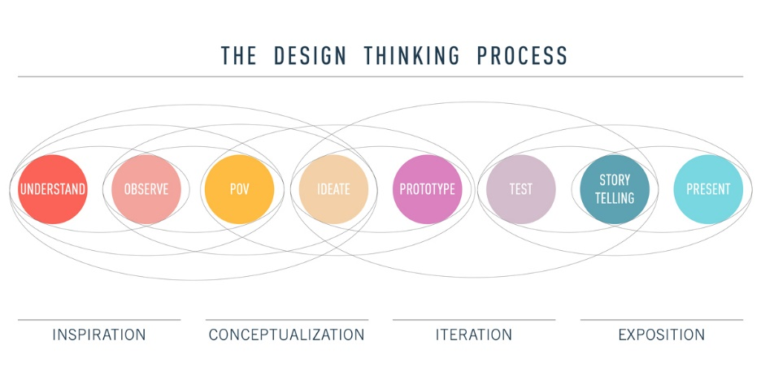

During the inspiration stage, the UX designer seeks to understand and observe. To do this, they conduct extensive research and competitor analysis in order to fully grasp the problem or challenge they are setting out to solve. This involves interviewing those who are, or will be, directly engaged with the product.

The designer then uses this feedback to identify the user’s goals, emotions, pain-points and behaviour. All of this information helps to form user personas. The next step is to consider what these personas are trying to accomplish when using a particular product, and the journey they will take to do so. The designer considers information architecture and uses various techniques, such as card sorting, to map out user flows.

**What is wireframing?**

Wireframing is a way to design a website service at the structural level. A wireframe is commonly used to layout content and functionality on a page which takes into account user needs and user journeys. Wireframes are used early in the development process to establish the basic structure of a page before visual design and content is added.

**Wireframing is essential in UI design**

A wireframe is a layout of a web page that demonstrates what interface elements will exist on key pages. It is a critical part of the interaction design process.

The aim of a wireframe is to provide a visual understanding of a page early in a project to get stakeholder and project team approval before the creative phase gets underway.

**Advantages of Wireframing**

One of the great advantages of wireframing is that it provides an early visual that can be used to review with the client. Users can also review it as an early feedback mechanism for prototype usability tests.

**Disadvantages of Wireframing**

As the wireframes do not include any design, or account for technical implications, it is not always easy for the client to grasp the concept. The designer will also have to translate the wireframes into a design, so communication to support the wireframe is often needed to explain why page elements are positioned as they are.

**1.Sketch**

Being able to make universal changes — whether it's through their library of symbols, layer styles, or text styles, or its smooth resizing and alignment features — saves designers time to deliver consistent prototypes. It takes out what’s tedious and lets designers jump in and create.

**2. Proto.io**

In their own words, Proto.io says using their UI design software results in "Prototypes that feel real." And Proto.io delivers on this, giving you what you need to create, organize, integrate, and test accurate mock-ups.

**3. Adobe XD**

It's hard to knock Adobe off of their status as royalty in design software — their kingdom of design products reigns in the creative cloud. Adobe XD offers vector-based user interface tools for creating prototypes and mockups with an interface that’s familiar to anyone who has used other Adobe products.

**4. Figma**

Figma lets designers build dynamic prototypes and mockups, test them for usability, and sync up all of the progress. Figma allows for a collaborative environment where multiple people can work on a project at the same time, much like Google Docs — letting you see who has it open for real-time collaboration. You’ll see who’s working and what they’re doing.

**5 Wireframe.cc**

Wireframes don’t have to be complicated, and keeping them simple lets them communicate in a straightforward way how a design needs to be structured.

‍Wireframe.cc keeps their wireframing tools focused on minimalism. Intentionally limiting the color palette and using simple rectangular elements — along with an uncomplicated interface — lets UX designers construct a low fidelity wireframe in a snap.

**UX Tool we used in Project is Figma:**

Figma is a collaborative web application for interface design, with additional offline features enabled by desktop applications for macOS and Windows. The feature set of Figma focuses on user interface and user experience design, with an emphasis on real-time collaboration, utilising a variety of vector graphics editor and prototyping tools. The Figma mobile app for Android and iOS allows viewing and interacting with Figma prototypes in real-time on mobile and tablet devices.

**Screenshot:**

UX/UI of the pages completed  
1. Landing page

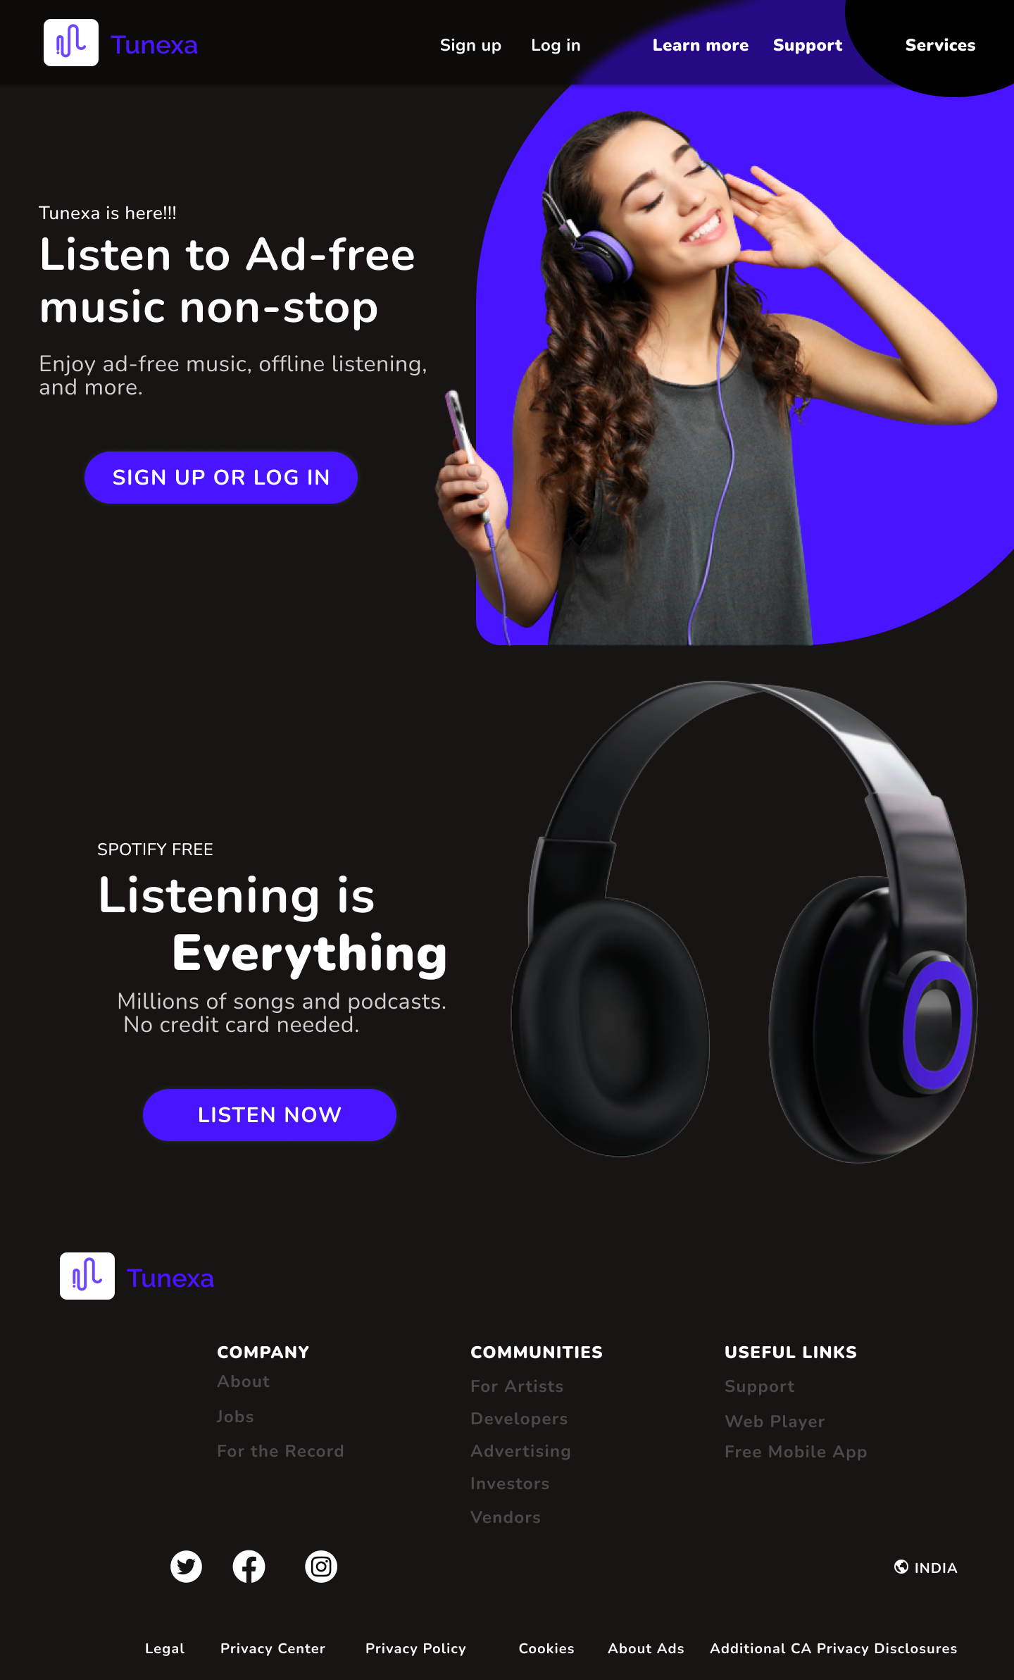

2. Login page

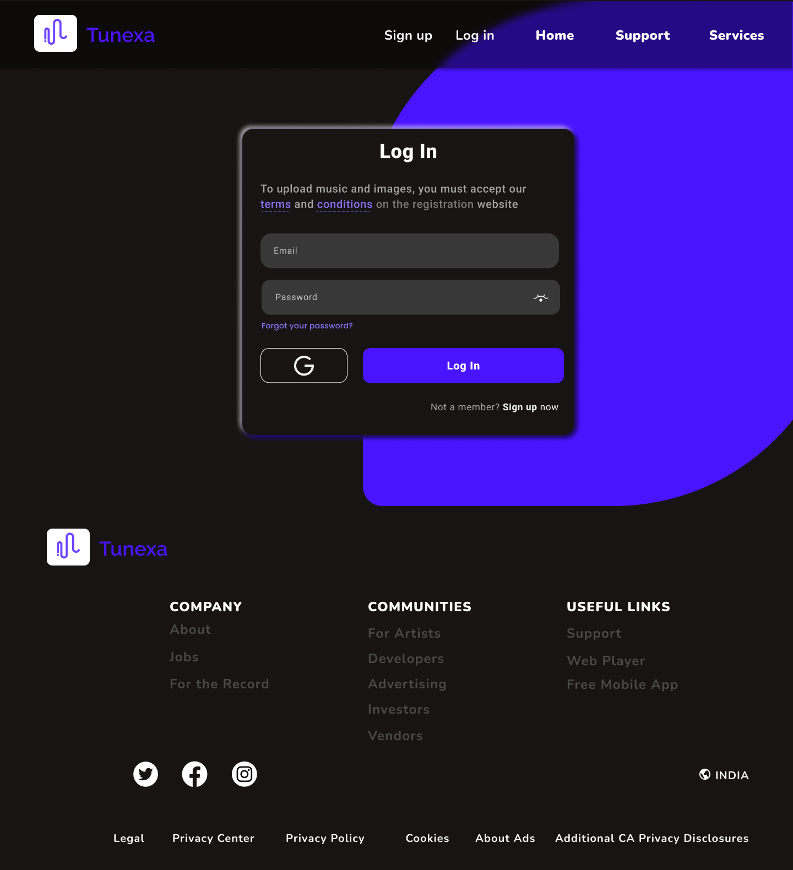

3. Signup page

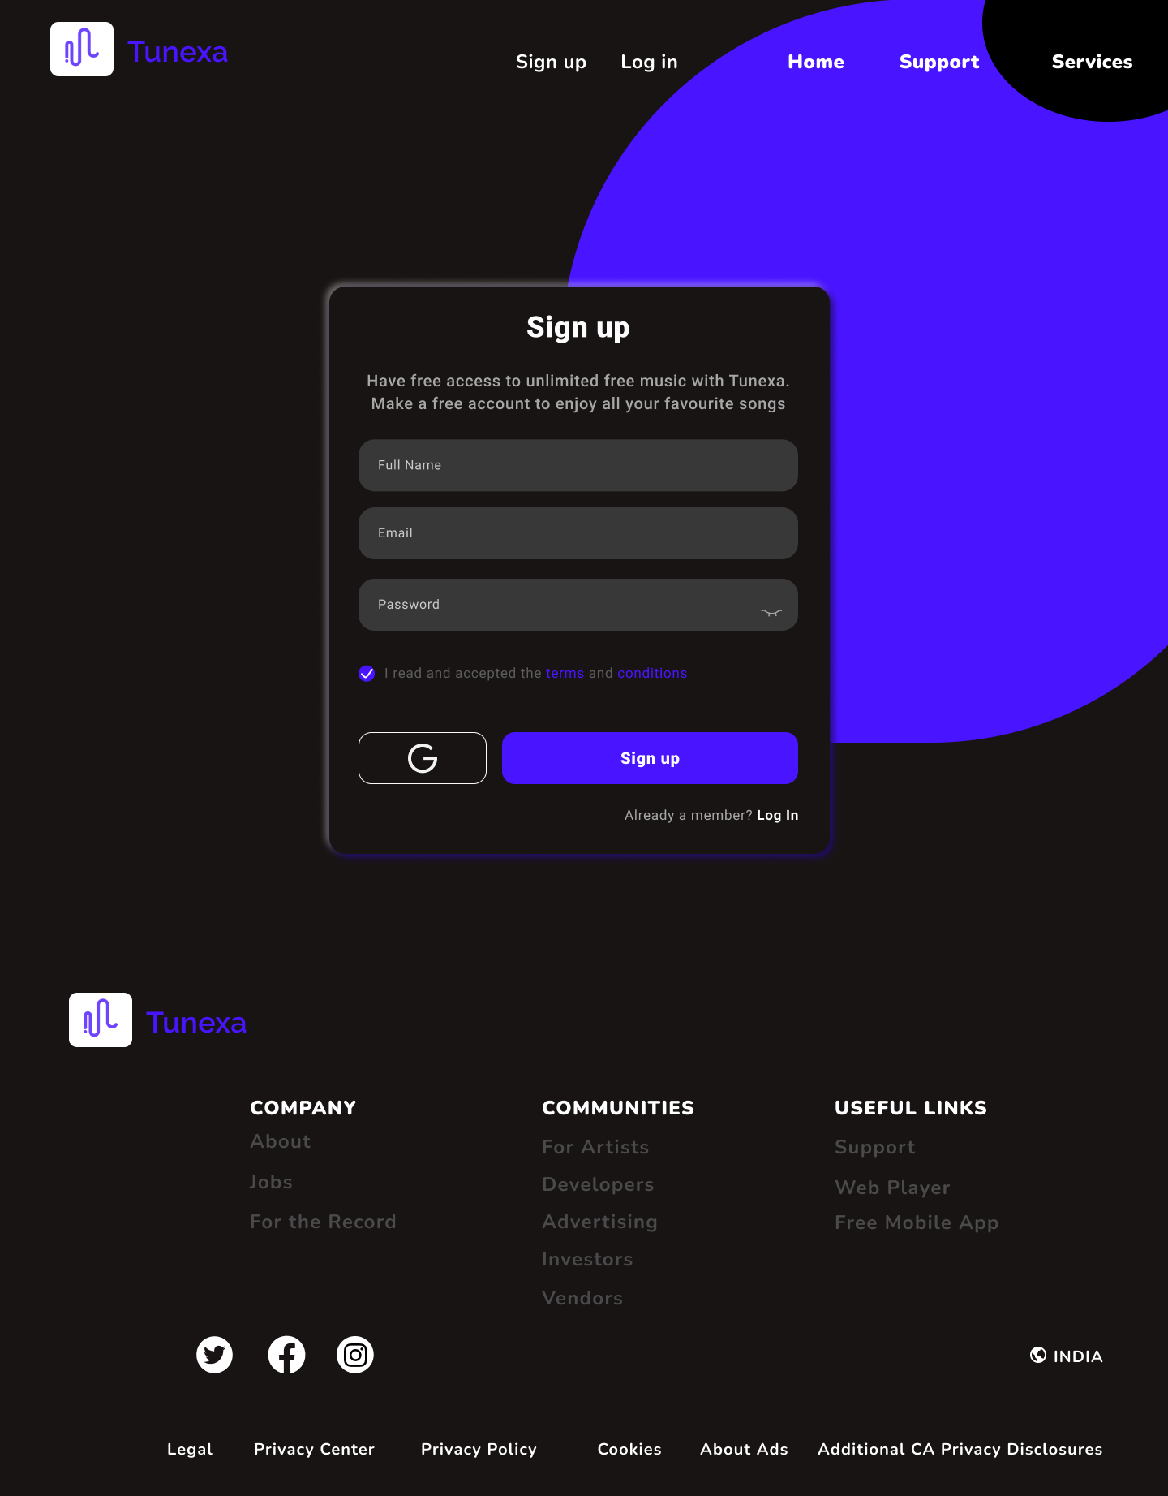

4. Home page

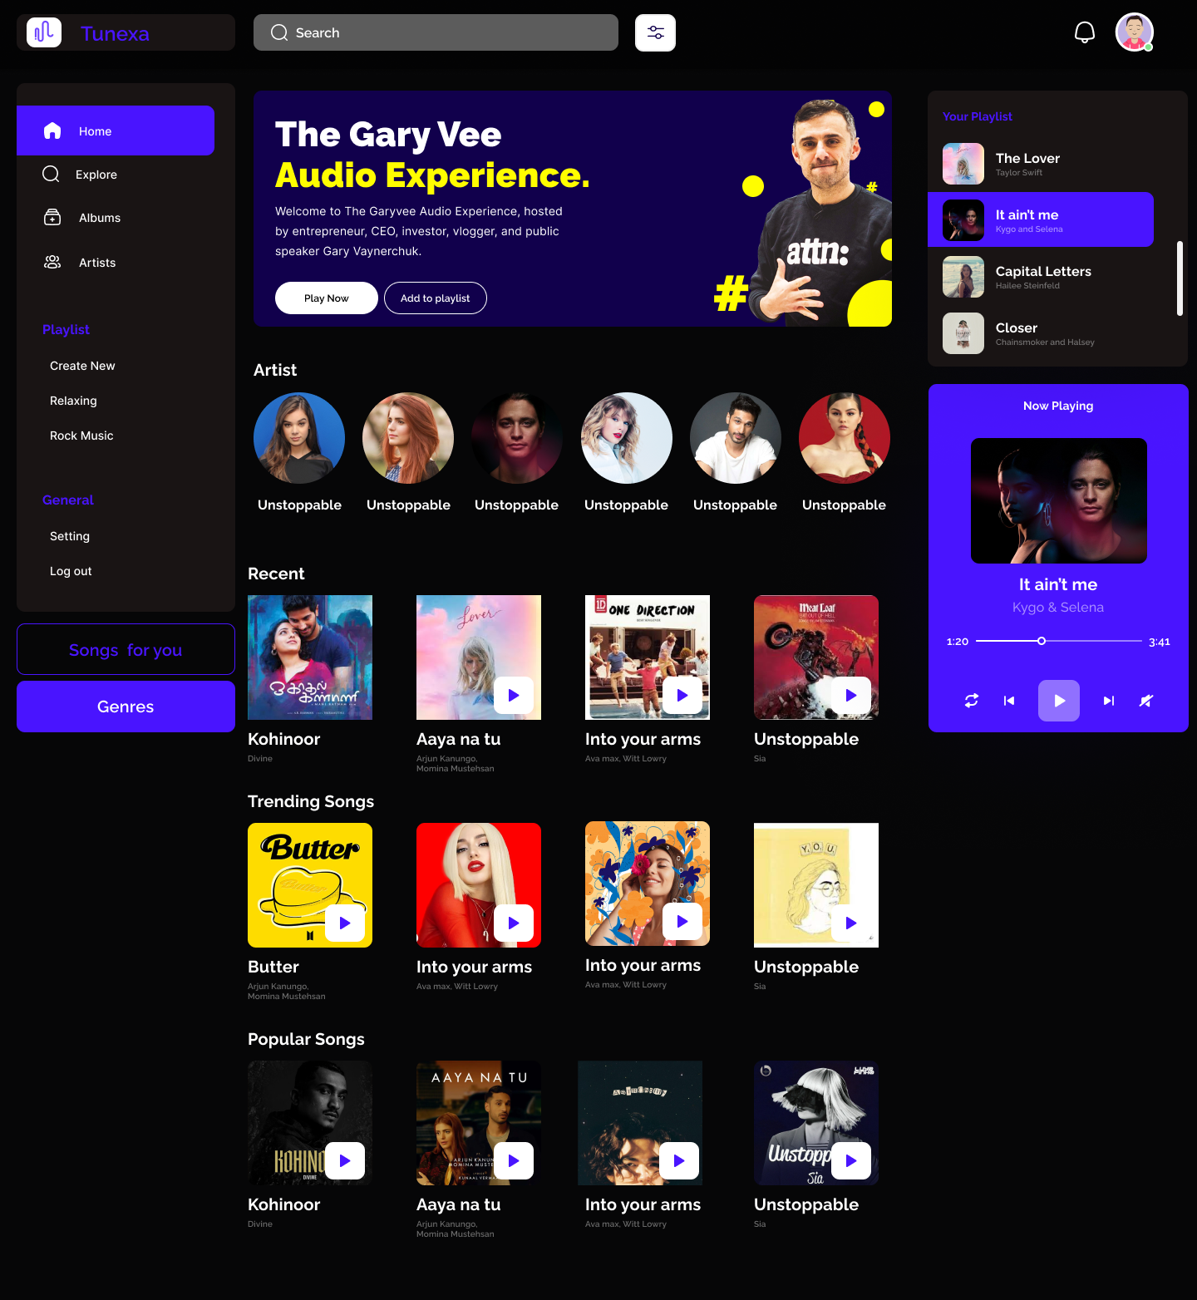

5. Search page

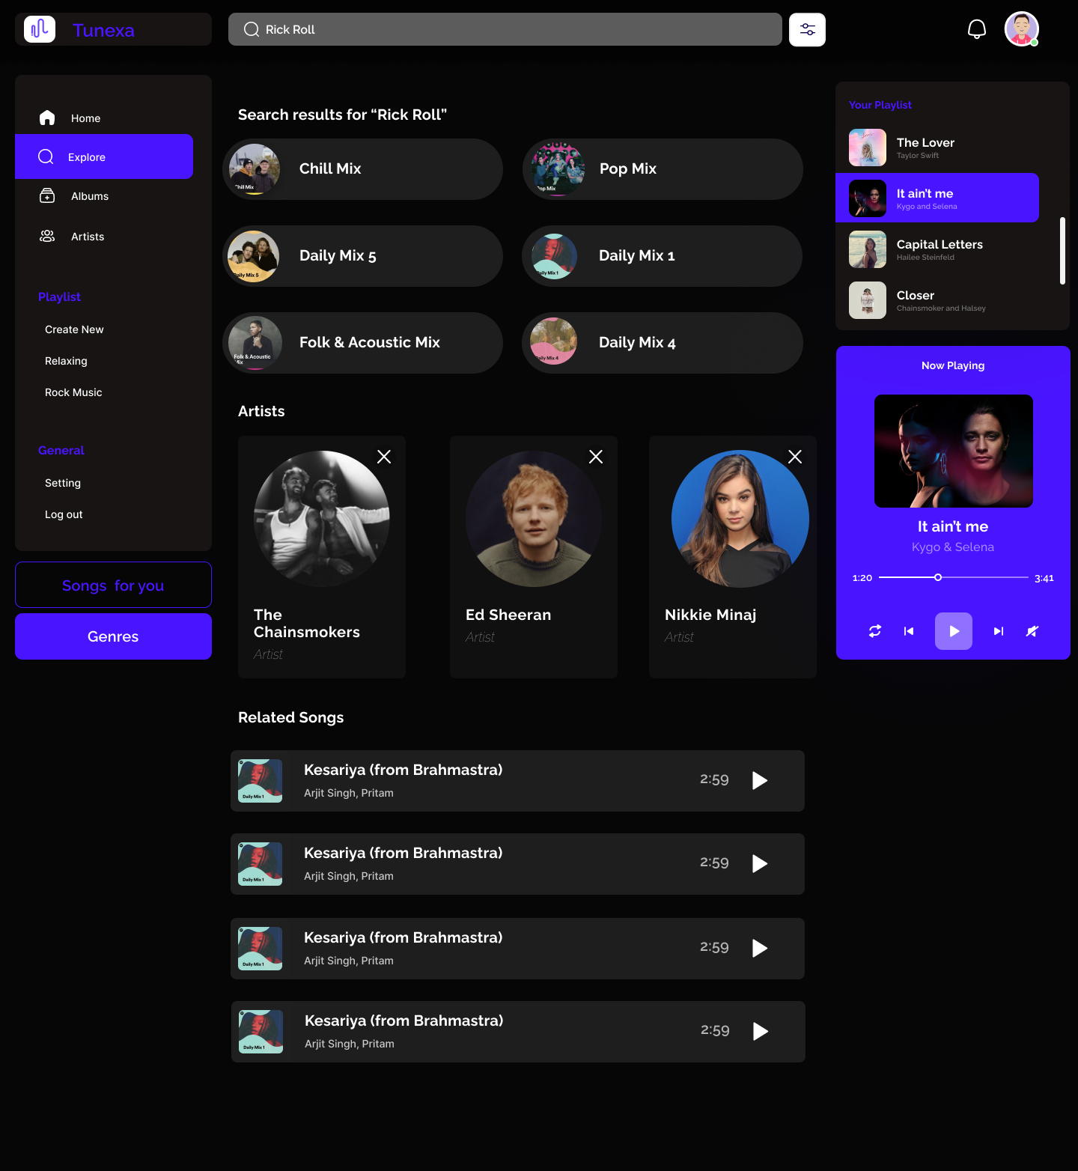

6. Album page

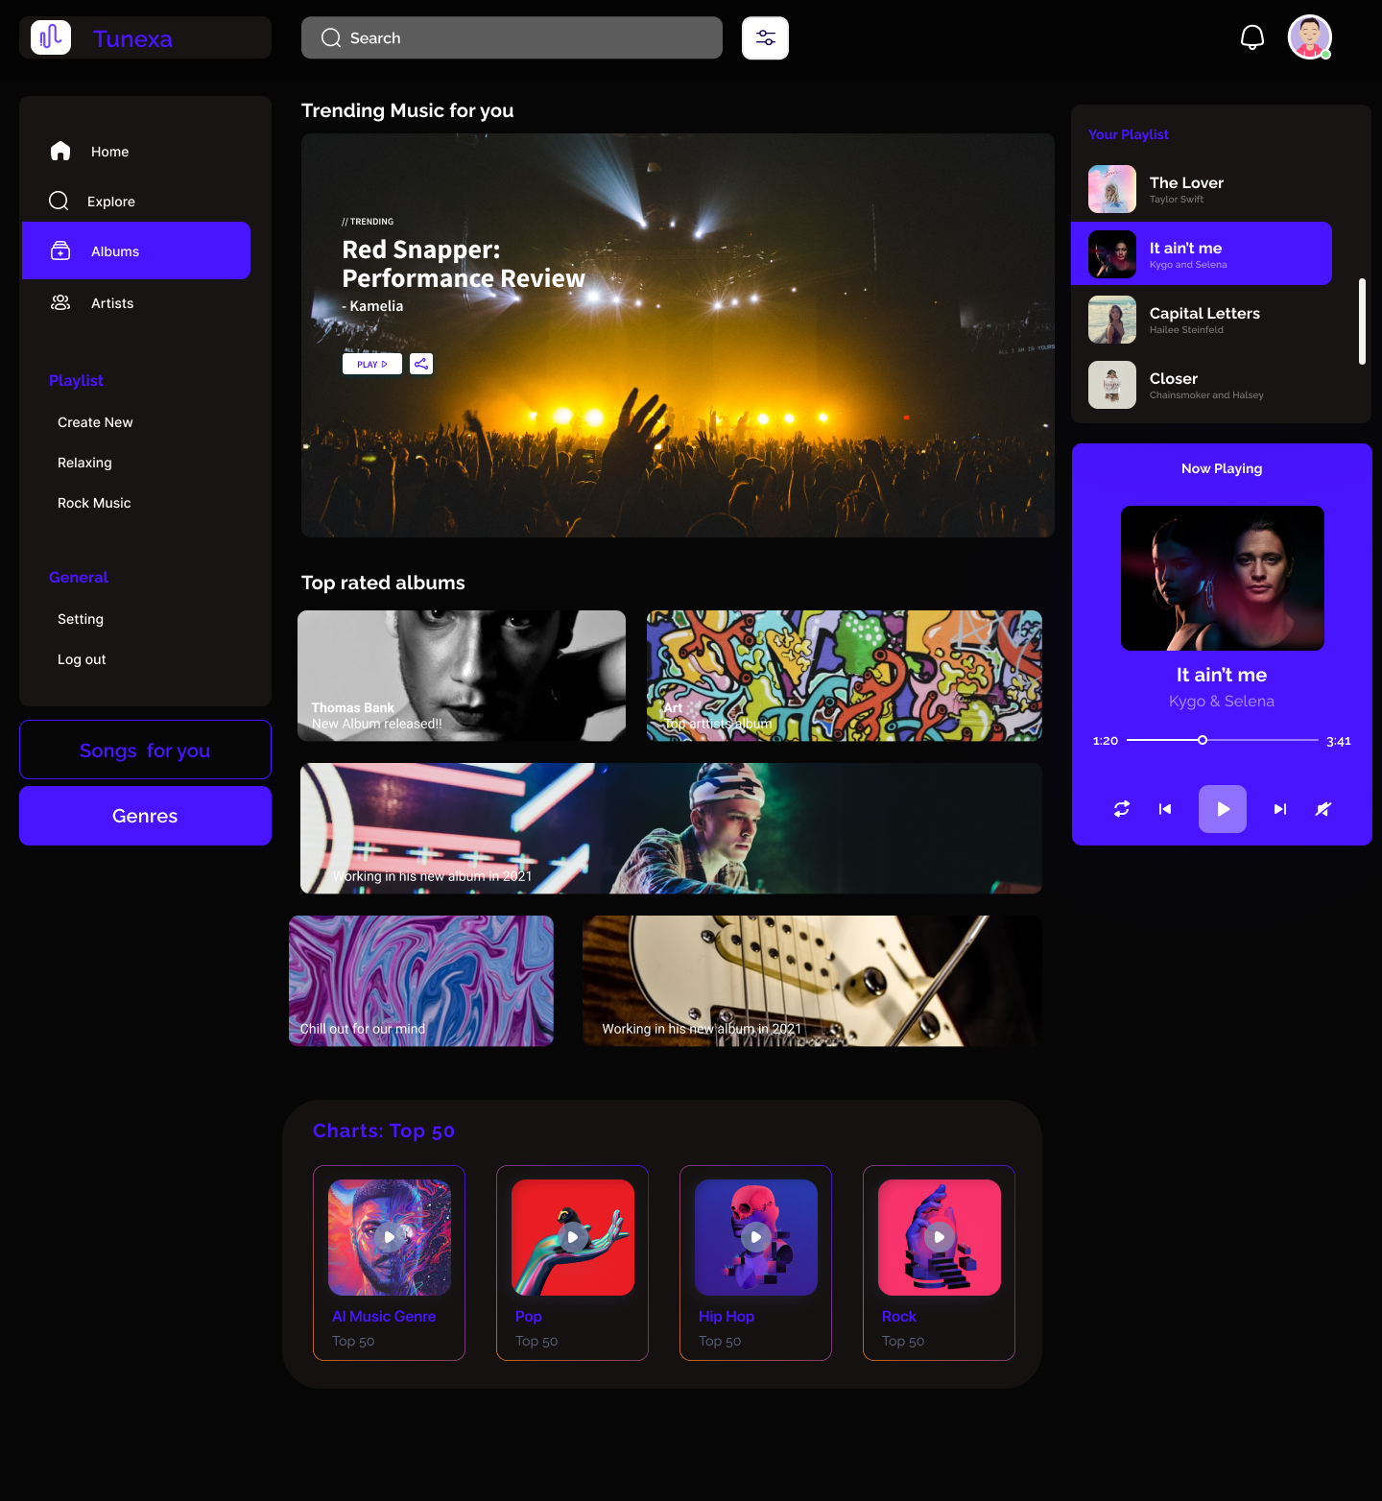

7. Artist page

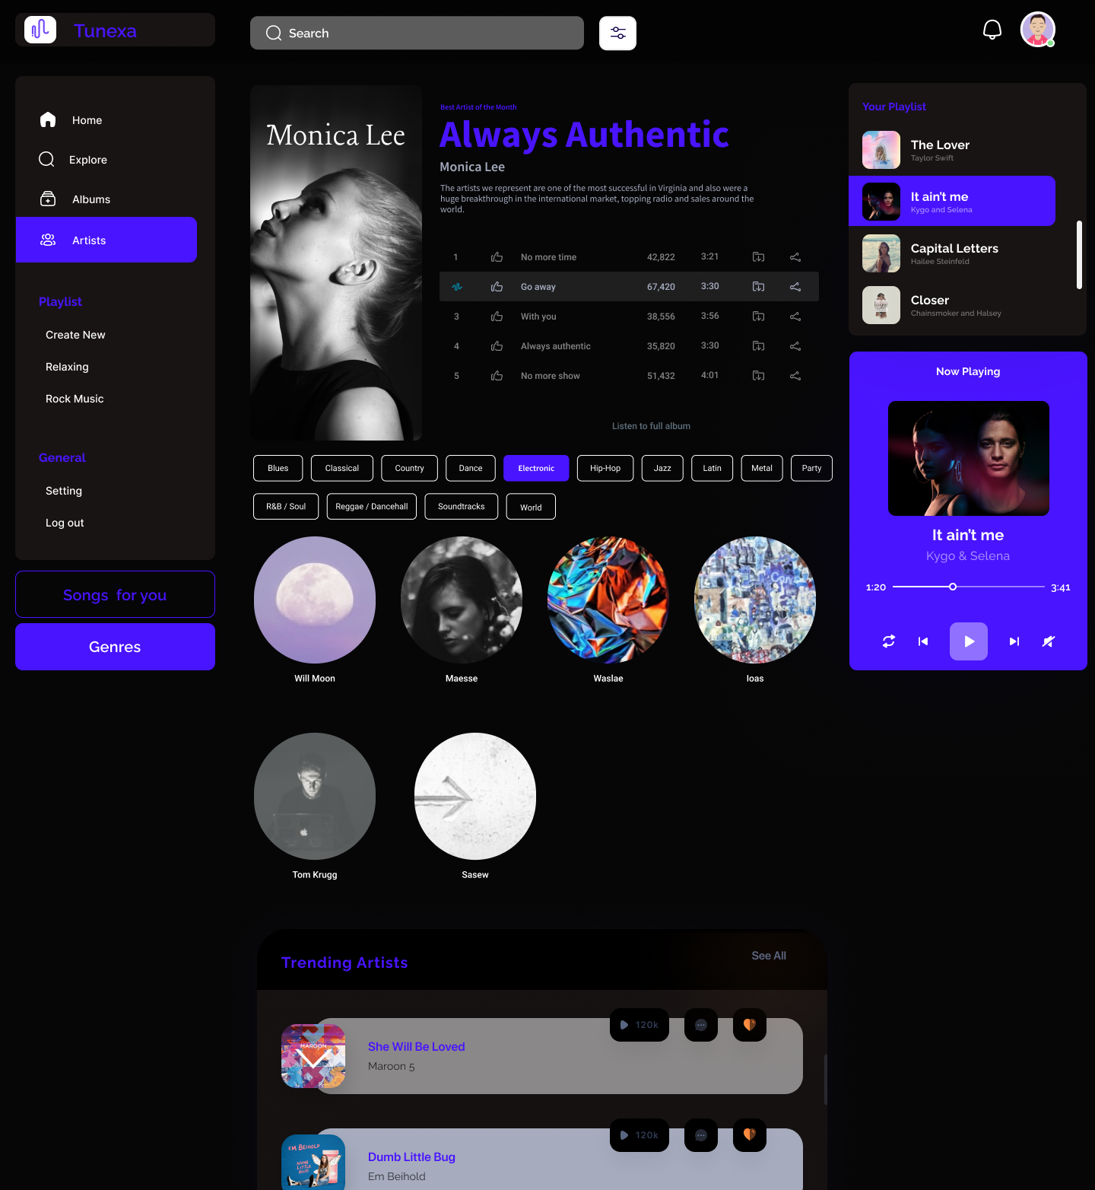

**Conclusion:** Successfully created website prototype using the Figma tool. Linked all the pages together to make a functional prototyped website.